

## Deccan Education Society’s

FERGUSSON COLLEGE (AUTONOMOUS),PUNE-4

# Department of Computer Science

A

Project Report On

# Online Optical Shop

By

1. Gayatri Patil 226206
2. Purva Kale 226217
3. Revati Jadhav 226218

[2022-2023]

Deccan Education Society’s

FERGUSSON COLLEGE (AUTONOMOUS), PUNE-4

**Department of Computer Science**

A

Project

Report on

Online Optical shop

In partial fulfillment of requirements of the completion of F.Y.M.Sc (C.S.)Semester-I

**Master of Science Computer Science**

**(CSC4106) Computer Science project-1**

Submitted By:

##### Gayatri Patil 226206

##### Purva Kale 226217

##### Revati Jadhav 226218

Under the guidance of:

**Mr. Irfan Khatik**

# 

# 

# CERTIFICATE

#### This is to certify that the project entitled **ONLINE OPTICIAN SHOP**

#### Completed by

#### 1.Gayatri Patil

#### 2.Purva Kale

#### 3.Revati Jadhav

#### in partial fulfillment of the requirement of the completion of M.Sc(C.S.)Semester-I, has been carried out by team under my guidance satisfactorily during the academic year 2022-2023.

**Place** : Pune

**Date**: / /2023

Mr.Irfan Khatik (Dr.Kavita A.Khobragade)

##### Project Guide Head, Computer Science

##### Department

**Internal Examiner: External Examiner:**

**ACKNOWLEDGEMENT**

We have taken efforts in this project. However, it would not have been possible without the kind support and help of **Mr. Irfan Khatik (**Project guide). We would like to extend our sincere thanks to all who helped us throughout the project.

We are highly indebted of Irfan sir for her guidance and constant supervision as well as for providing necessary information regarding the project & also for their support in completing the project.

Our thanks and appreciations also go to our batch mates in developing the project and people who have willingly helped us out with their abilities.

|  |  |
| --- | --- |
| **Gayatri patil** | **226206** |
| **Purva kale** | **226217** |
| **Revati Jadhav** | **226218** |

|  |  |  |  |
| --- | --- | --- | --- |
| **Sr. No.** |  | **Topic** | **Page Number** |
| **1.** |  | **Introduction** |  |
|  | **1.1** | **Existing System & Problem Definition** |  |
|  | **1.2** | **Need for the New system** |  |
|  | **1.3** | **Overview of the Project** |  |
| **2.** |  | **Analysis** |  |
|  | **2.1** | **Feasibility Study** |  |
|  | **2.2** | **Hardware Requirements** |  |
| **3** . |  | **Design** |  |
|  | **3.1** | **Database Table Designing** |  |
|  | **3.2** | **UML Diagram**  **Sequence Diagram, Activity Diagram, Deployment Diagram** |  |
|  | **3.3** | **Input and Output Screens And Reports** |  |
| **4.** |  | **Testing** |  |
|  | **4.1** | **Test cases and Test Results** |  |
| **5.** |  | **Limitations and Future Enhancements** |  |
| **6.** |  | **Conclusion** |  |
| **7.** |  | **References and Bibliography** |  |

# Index

1. **INTRODUCTION**
2. This Optician Shop Management system using php was designed to manage the optician information such to produce optical important information Business is one of the most important economy generators for each country and since the dawn of the twentieth century, all business companies turned to technology to better improve their business chances and qualities. Thus, such is reasons of the developed for the optical business, where it will be implemented in each of the shop outlet of an optical company. The system name is Optical Shop Management(OSM). The system is developed for the purpose of making management much more systematic, secure and efficient OSM consist of modules which are login, transaction management and financial management.
3. Main feature you can add customer details who want to buy your product you can modify or edit customer details you can your Add Product details, spectacles details, sunglass, Computer glass also you can edit product details use sale product from for sale information and generate bill .you can also print receipt. generate report for customer, product and sales.
4. Optical Shop Management project is implemented in PHP language. For database MYSQL has been used. There also we used HTML and CSS. This is an online shopping project for purchasing optical glasses, frames and others eye wears. In this project have 2 module firstly here admin can login, after than login admin can details with delete option. You can also delete the through frame of the deletion option admin can view booked frame by user. In this Optical shop management project application user can register account and then can fill a login form after
5. that user can see different types of frames and consult with your problem and book frame with online payment.

**1.1 Problem Definition**

Managing your online optical shop management system may seem tricky, but an optical shop management system is a part of E-commerce Services System (Application support direct contact and users)

* Existing Systems are not user friendly.
* Admin panel need improvement for getting more options for easy working.
* Optical shop management system searching option need more filters.

### 1.2 Need for New System

There is always a need of a system that will perform to search and buy

Now optical shop online shopping, online according to services

Thus, there is a big need of online Optical Shopping services, which

provides all the Above- mentioned facilities and many more.

The Problem statement of this project is the current management system

is filing system to records the sales, customers, staff, stock record and

there are no well inventory management.

.

**1.3 Overview of the Project**

The project is basically targeted at those people who would

like to Optical shop and have an internet access.

This is a web application it contains most of the features of an online

Shopping website. This application runs over the internet. So, it is

Available for customers 24X7. They can shop anytime and from any

Where. payment Option is through credit card. This system also main-

tains stock of all the products being sold online.

Optical shop management is implemented in PHP language. For

Database MySQL, has been used. They also used HTML & CSS.

This is an online shopping project for purchasing optical glasses,

Frames and other eye wears. In this project have 2 module first is

is user and second one is admin. Firstly, here admin can login, after

than login admin can add frame and view frame and add glass and

view glass and view glass details with delete option. You can also

delete through frame of the deletion option admin can view booked

frame by user. In this Optical shop project application user can

register account and them can fill a login from that, user can see

different type of frame and consult with your problem and book

and consult with your problem and book frame with online payment.

##### 

##### 

##### Features of Online Optical Shop are:

* + - Online Shopping Websites.
    - When product Stock goes below reorder level it’s reflect on its admin homepage.
    - Being online its available to user 24x7.
    - Now customer do not need to visit optical store.
    - They can buy Optical product online

##### Goal of Online Optical Shop are:

* The project is basically targeted at those people who would like

Optical Shop and have an Internet access.

* Finally, Glass lovers curious in comparing the prices for various glasses for their selected category.
* To make a database that is consistent, reliable and secure.
* To provide correct, complete, ongoing information.
* To make good documentation to facilitate possible future enhancement.

**2.Analysis**

* 1. **Feasibility Study**

### Technical feasibility

This system is self-explanting and does not need any entire sophisticated training. A System has been built by concentrating on the graphical uses interface concept, the Application can also be handle very easily with a novice users. The overall that a user need to get trained is less than 15 minutes

* + - HTML
    - CSS
    - JAVASCRIPT
    - Notepad++
    - Bootstrap
    - PHP
    - MySQL
    - xampp

Each of these technologies is freely available and the technical skills required are manageable.

Initially the website will be hosted on the local host but later for implementations it will be hosted in a paid web hosting space with sufficient bandwidth from these aspects as of now the project Optically technically feasible.

.

### Economic Feasibility

Its refers to the benefits or Outcomes we are deriving from the product as compared to the total cost we are spending for developing the benefits are more less the same as the older system then it is not feasible to develop the product.

.

### Operational Feasibility

It refers to the feasibility of the product to be operational. some product may work very well at the design and implementation but many fail in the real time environment.it introduces the study of human resources required and their technical expertise.

* 1. **Hardware Requirement**

**Hardware Specification**

Minimum system requirements are:

* + - Ram: 4 GB
    - Processor: AMDA processor
    - Hard Drive: 500 GB

**Platform**

**Platforms used to build Optical Online shop are:**

* + - Operating System: Windows
    - Language: HTML, CSS, JavaScript, PHP
    - Database: My SQL

**3.DESIGN**

* 1. **Database Table Designing (ER diagram)**

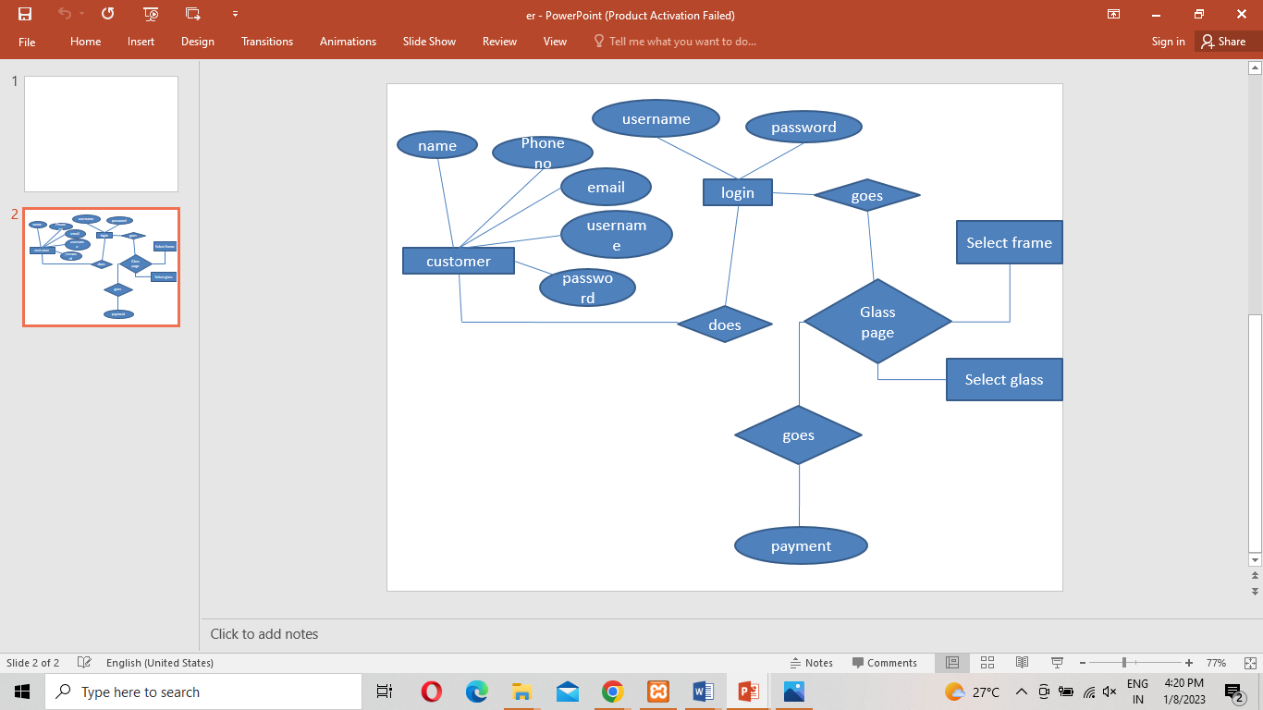

**3.2 UML Diagram**

**Sequence Diagram**

**Admin side**

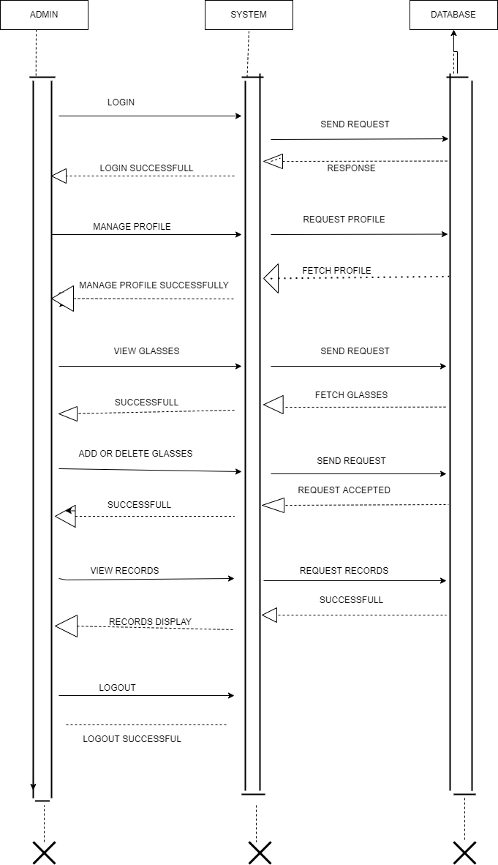

**User side:**

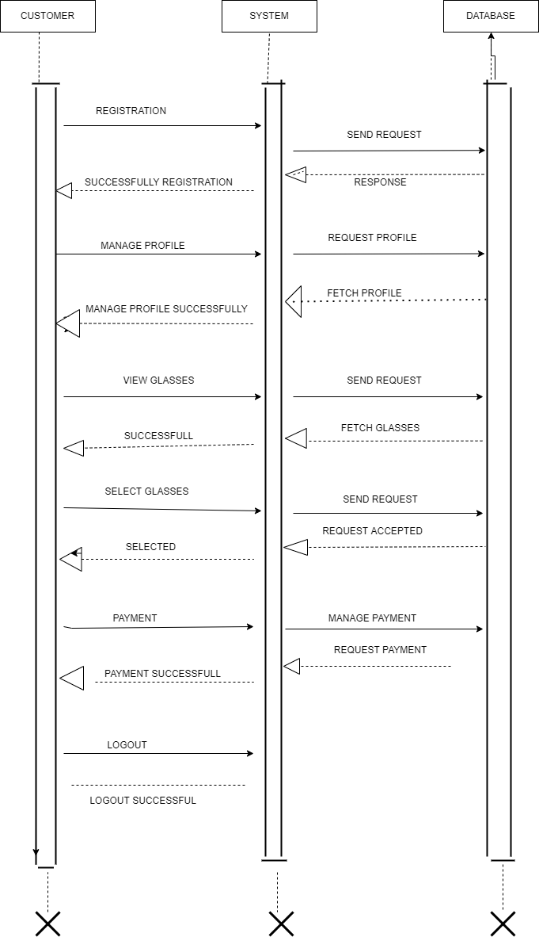

**Activity Diagram**

**Admin side**

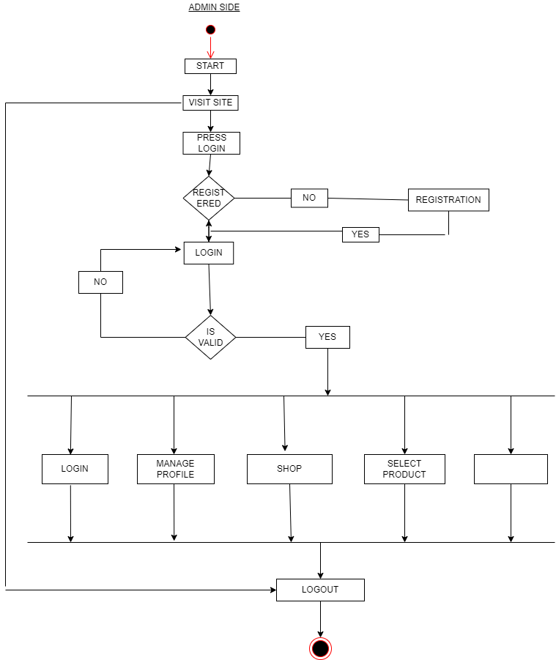

**User side**

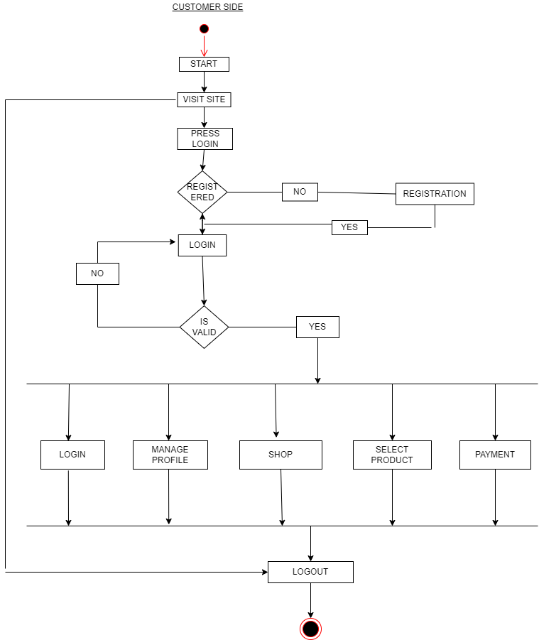

**Component Diagram**

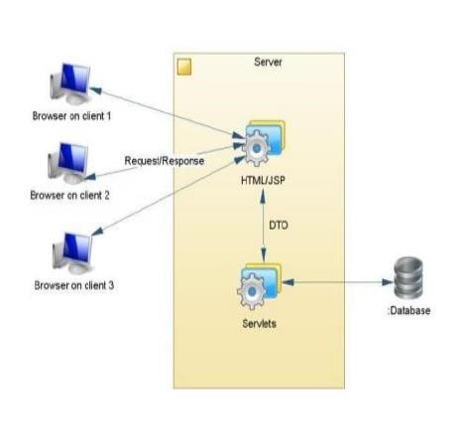

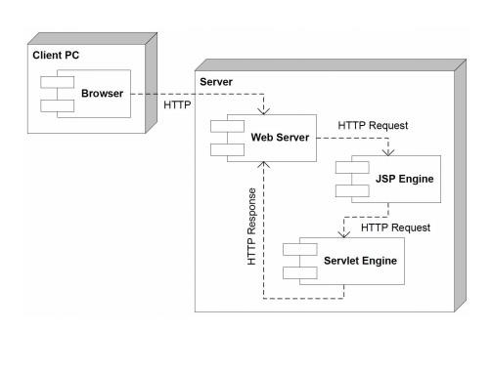**Deployment Diagram:**

**3.3 Input and Output Screens**

**Homepage**

sssss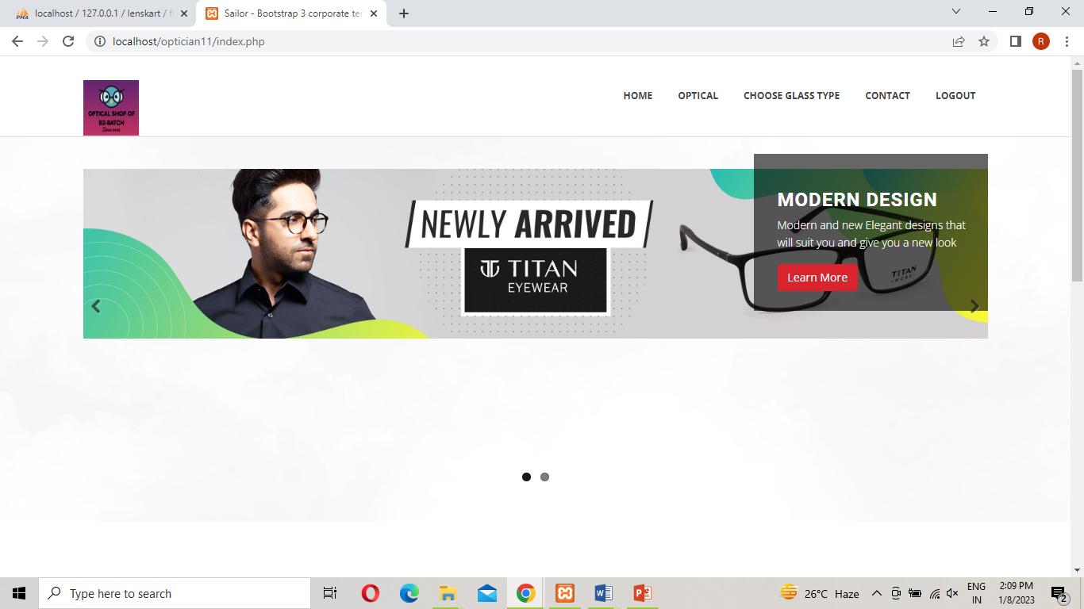

User side(register)

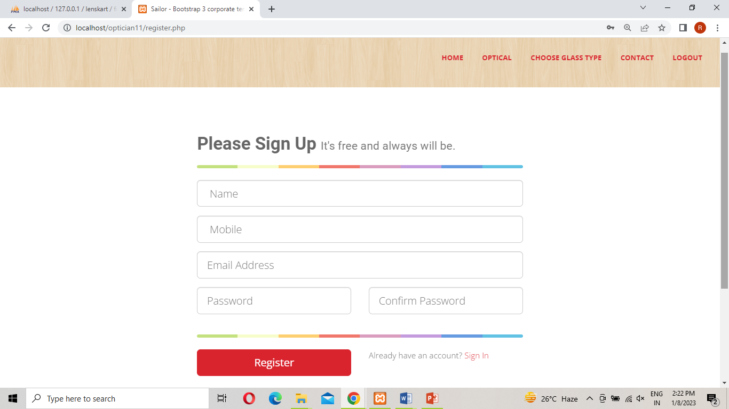

Admin side

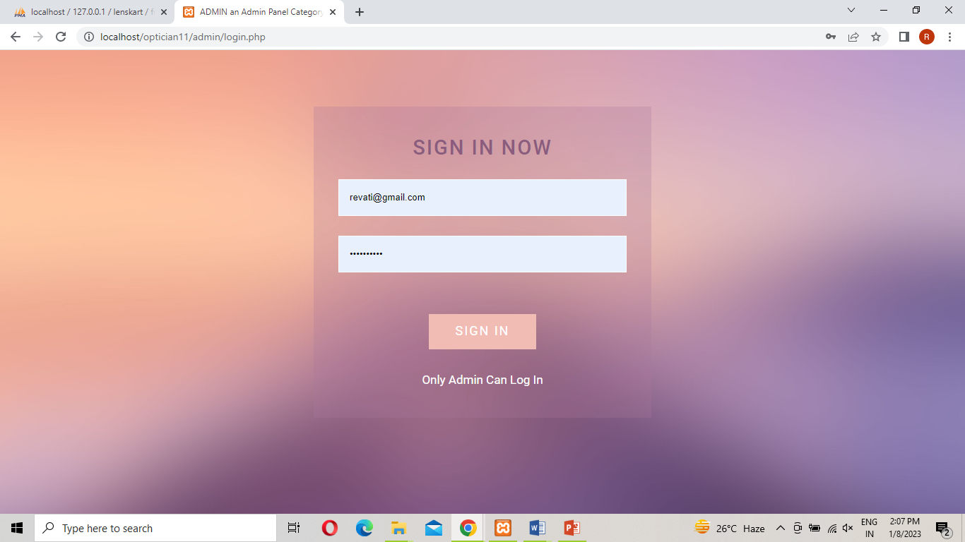

User side login

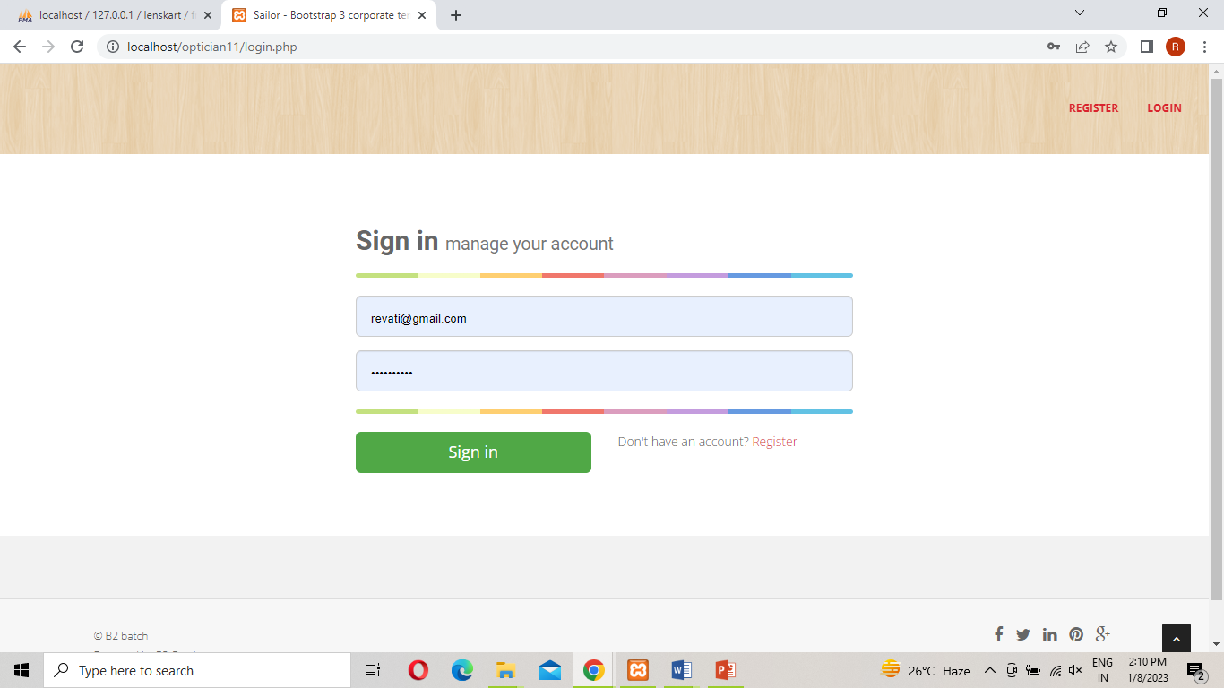

**New frame pages:**

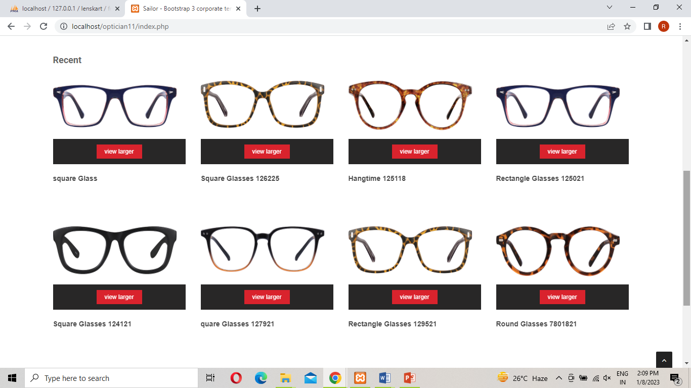

**Glass types**

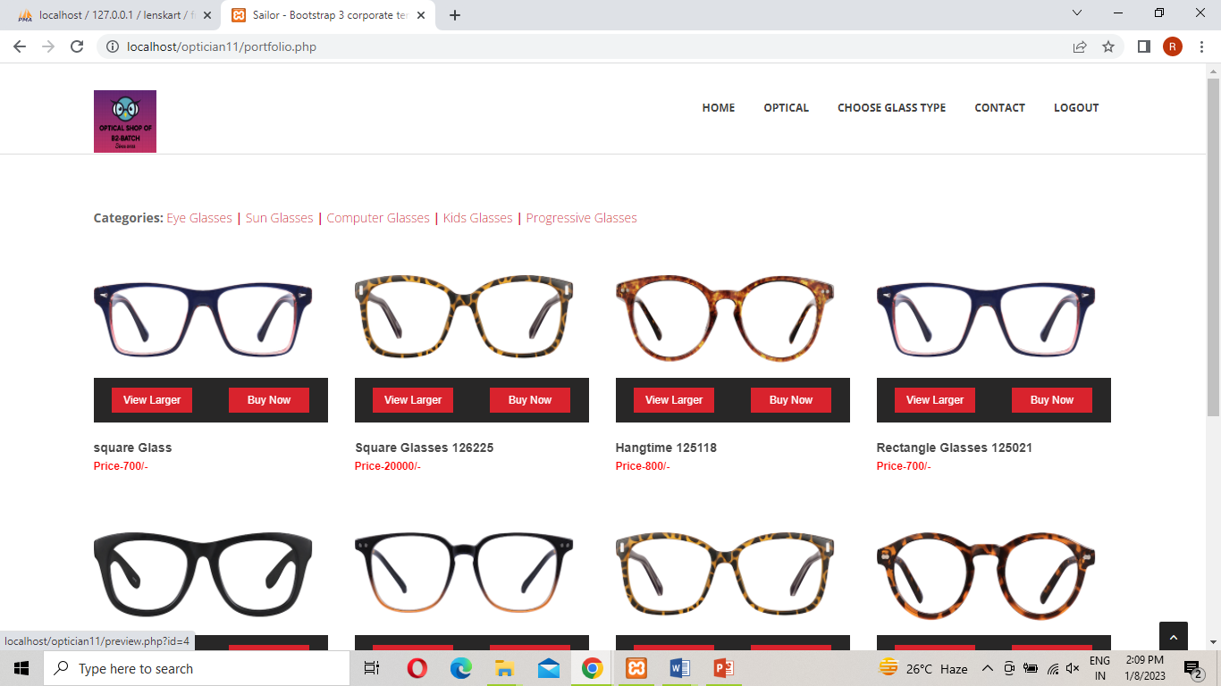

**Glass Details**

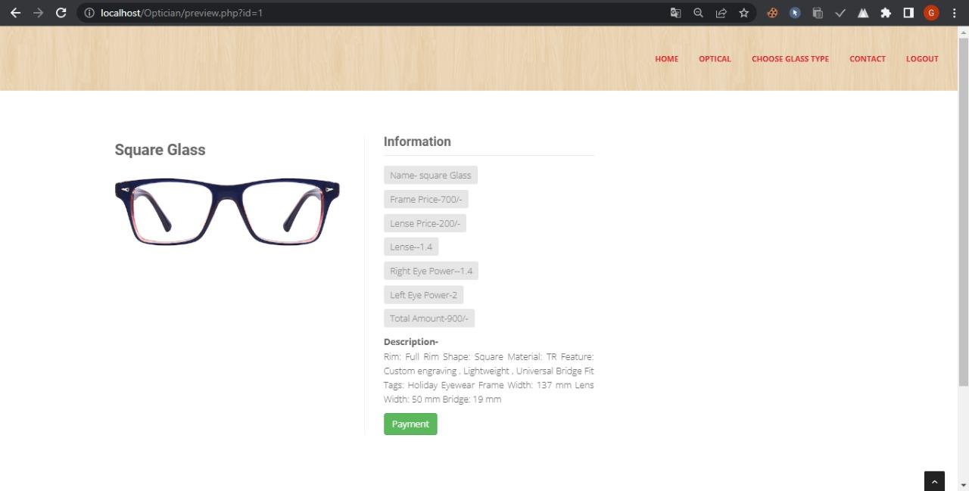

**Payment**

### 

**Admin**

**Dashboard**

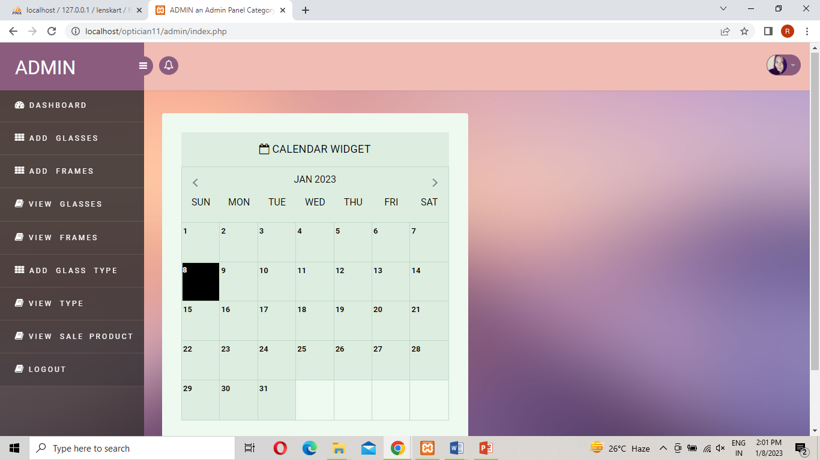

AddGlass: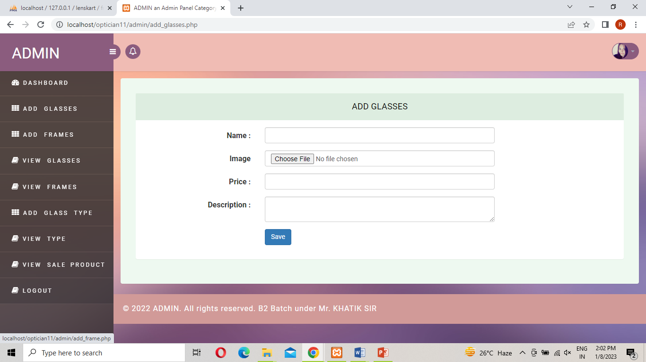

Viewglass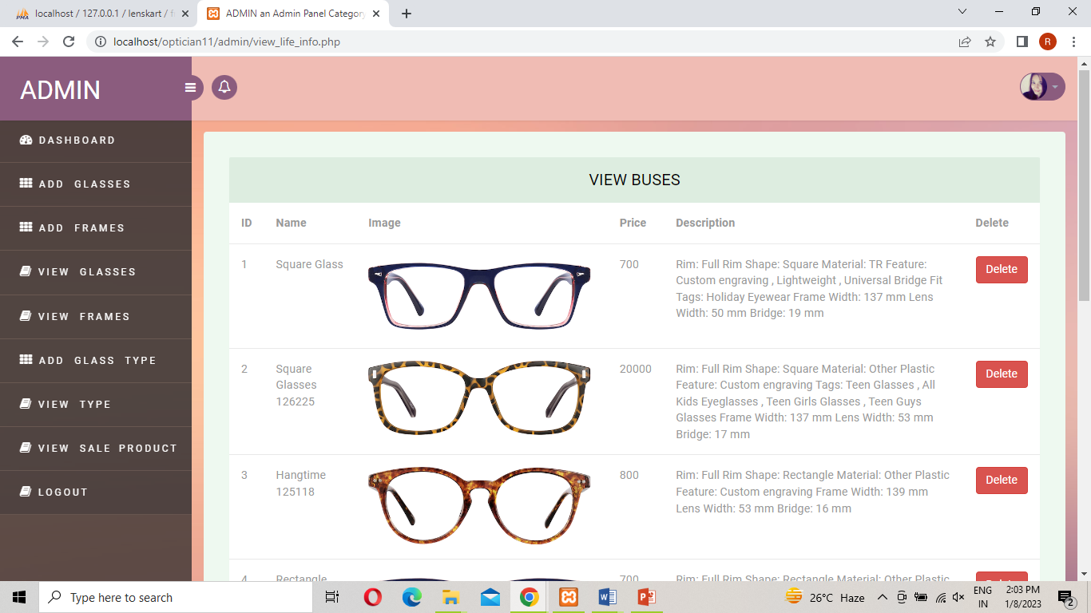

# 4. Testing

**4.1Test Case Design**

|  |  |  |  |  |  |
| --- | --- | --- | --- | --- | --- |
| Sr.no | Page | InputCase | Expectedcase | ActualResult | Pass/Fail |
| 1. | Sign up Page | 1. Wrong Email input   2]Miss matched Password | Enter valid Email id  Please enter valid password | Enter valid Email  Enter valid password | Pass  Pass |
| 2. | LoginPage | 1. Empty name 2. empty phone no   3]empty email  4]wrong password | Enter name  Enter phone no  Enter valid email  Enter valid password | Enter name  Enter phone no  Enter valid email  Enter valid password | Pass  Pass  Pass  pass |
| 3. | Choose frame | choose two frame at a time | Choose one frame at a time | Choose one frame at a time | Pass |
| 4. | Choose  glass | Choose two frame at a time | Choose one at a time | Choose one at a time | Pass |
| 5. | Sign out | Click sign out button | Sign out | Sign out | Pass |

# 5.Limitations and Future Enhancement

Besides the above achievements and the successful completion of the project, we still feel the project has some limitations, listed as below:

* It is not a large-scale system.

* Only limited information provided by this system.

**Future Enhancement**

* This project can be made for all browser/ OS.
* Higher Security features can be included in this
* Program scheduling can also be included in this project.
* This software can be developed to use as tutorial to

teach basic concepts of OS to new users.

* Automation through SMS service can be implemented

in this project for few features

# 6.Conclusion

The project was successfully designed and is tested for accuracy and quality. This system has been developed for OM OPTICAL SHOP. The current system is a manual system. In order to overcome the drawbacks in the current system a decision to automate some of the department of the optical shop business. It reduces drawback of manual system like provide security time consuming, do not require any extra storage, easily modify the data, fast and accurate. This System provide better service to the customer.

# 7.References and Bibliography

#### **FOR PHP INSTALLATION**

#### **·** [**http://www.php.net/**](http://www.php.net/)

#### **FOR DEPLOYMENT AND PACKING ON SERVER**

#### [**www.developer.com**](http://www.developer.com/)

#### [**www.15seconds.com**](http://www.15seconds.com/)

#### [**www.projecttunnel.com**](http://www.projecttunnel.com/)

#### **FOR MY SQL**

#### **·** [**http://www.mysql.com/**](http://www.mysql.com/)

#### **FOR CSS**

#### **·** [**http://cssed.sourceforge.net/**](http://cssed.sourceforge.net/)